The Copenhagen Networks Study:
Measuring Social Networks across Communication Channels

Case Study Report

Qingan Xu
MSSP 6070: Practical Programming for Data Science
Extra Credit Assignment
School of Social Policy & Practice, University of Pennsylvania
2 November 2026

Executive Summary
The Copenhagen Networks Study (CNS) gave more than 700 first-year students at the Technical University of Denmark smartphones; its 2019 release covers four weeks of their physical proximity, calls, texts, and Facebook friendships (Sapiezynski et al., “Interaction Data” 1). Proximity clustered in weekday working hours, while texts and calls continued into evenings and weekends, yet the layers overlap: most pairs who called each other were also within Bluetooth range at least once (6; table A3). The case shows that a network’s measured structure depends on the channel and time window, and that privacy must be designed into such studies from the start.
Introduction
Unlike surveys, which capture whom people say they know, phones record how they interact, and CNS had almost ten times as many participants as earlier high-resolution phone studies such as MIT’s Reality Mining (Sapiezynski et al., “Interaction Data” 2). Its goals included measuring networks across communication modes, modeling spreading processes, and advancing privacy research (1). The release holds Bluetooth scans among 706 participants, 3,600 calls, 24,333 texts, 6,429 Facebook friendships, and gender, all without content (3–6).
Case Analysis
Key issues. The first issue is privacy versus usefulness: for data this rich, it is “virtually impossible to provide guarantees regarding re-identification of users while preserving its value” (Sapiezynski et al., “Interaction Data” 1). The authors therefore withheld location and Wi-Fi data, used relative timestamps, and delayed release past the EU’s two-year phone-record retention period (1–2). The second is measurement: Bluetooth records co-presence within about 10 meters, not conversation (3), and the median participant has data for only 81% of five-minute bins, with gaps clustered at night (4). Third, structure depends on aggregation: five-minute networks show many small groups that daily networks hide (6–7). Finally, the sample is narrow: freshmen at one technical university, 22% of them women (table A1).
Decision criteria. The release decision weighs four criteria: value for new research (its first aim), re-identification risk and harm to participants, GDPR compliance, and replicability of earlier published work (Sapiezynski et al., “Interaction Data” 1–2).
Assumptions. The data assume that phones detecting each other within a five-minute bin signal contact, that the strongest signal represents the pair (Sapiezynski et al., “Interaction Data” 3), and that study phones were participants’ primary phones (3–4). Gender is binary (6). The data begin on a Sunday (1); this report takes timestamp 0 as midnight, as activity patterns suggest.
Data analysis. The course notebook, adapted from the authors’ release (Sapiezynski et al., Copenhagen Networks Study) and modified to run in Colab (see appendix), loads each file with pandas and builds graphs with NetworkX. Its Bluetooth example turns rows linking two participants into undirected edges weighted by signal strength and draws each connected component. Its second example merges texts with genders on the shared user ID, the step behind any cross-layer analysis; women sent 41% of texts between participants of known gender (table A2). Added checks reproduced most headline numbers, such as median data availability (0.806), though texts outnumber calls seven to one, not ten to one (table A3). Across 40 weekday windows, the largest group holds a median 23% of active participants at five minutes but 70% at forty (table A3; fig. A1). Only 18% of proximity contacts fall in evenings or at weekends, against 49% of texts and 43% of calls (table A3; fig. A2).
Preferred alternative. Three options existed: publish all raw data; keep data behind the study’s access-controlled interface; or publish a minimized, delayed subset (Sapiezynski et al., “Interaction Data” 1–3). The authors’ choice, the third, best fits the criteria: it drops the most identifying data yet still supports the published network findings (table A3). Its cost is lost context: no locations, survey answers, or calendar dates.
Recommendations. Analysts should treat channels as complementary: 621 pairs ever called each other, but 79,530 were ever within Bluetooth range (table A3), so phone records alone miss the wider web of contact that matters for disease spread. They should match the time window to the process and report several, describe missing data before modeling, and build in privacy through data minimization, participant access to their own data, and delayed release (Sapiezynski et al., “Interaction Data” 1–2).
Program relevance. The MSSP+DA program trains students to use data analytics to reduce inequities in income, education, and health (“Social Policy”). Network data could target outreach to isolated students or plan epidemic control, already modeled with CNS data (Sapiezynski et al., “Interaction Data” 2), but they carry consent and re-identification risks, and a narrow sample cannot stand in for the populations social policy serves. Predicted outcome: reusing such data costs far less than repeated surveys and, with these safeguards, should yield more accurate and defensible network evidence.
Conclusion
CNS shows that a social network can be measured across channels at five-minute resolution, and that the picture depends on the channel and time window chosen. For social policy analytics, measurement choices and privacy safeguards are part of the evidence.

Works Cited
Sapiezynski, Piotr, et al. The Copenhagen Networks Study Interaction Data. figshare, 2019, https://doi.org/10.6084/m9.figshare.7267433.
Sapiezynski, Piotr, et al. “Interaction Data from the Copenhagen Networks Study.” Scientific Data, vol. 6, 2019, https://doi.org/10.1038/s41597-019-0325-x.
“Social Policy + Data Analytics, MSSP.” University of Pennsylvania Catalog, catalog.upenn.edu/graduate/programs/social-policy-data-analytics-mssp/. Accessed 2 Nov. 2026.

Appendix
All tables and figures below were produced with Copenhagen_​Networks_​Study_​Notebook_​Colab.ipynb, a copy of the course notebook adapted for Google Colab. The hard-coded instructor Drive folder was replaced with a DATA_DIR setting that falls back to searching MyDrive; a check that all five data files are present was added; the Bluetooth plot no longer fails when a time bin has only one group; and the SMS-by-gender matrix was transposed so its shading matches its labels. Part 4 of the notebook adds the checks reported here.
Table A1
Released Data Layers: Article versus Course Files
Layer | Records (article) | Records (files) | Participants (article) | Participants (files)
Bluetooth proximity | 5,474,289 | 5,474,289 | 706 | 706
Phone calls | 3,600 | 3,600 | 540 | 536
Text messages | 24,333 | 24,333 | 577 | 568
Facebook friendships | 6,429 | 6,429 | 800 | 800
Gender | 788 | 787 | 788 | 787
Note: Bluetooth records include 2,220,136 empty scans and 827,874 scans of devices outside the study; 2,426,279 records link two participants. Women are 22.0% of the 787 participants with a gender record. The article does not explain the small gaps in participant counts.
Source: Sapiezynski et al., “Interaction Data” 5–6; author’s analysis of Sapiezynski et al., Copenhagen Networks Study.
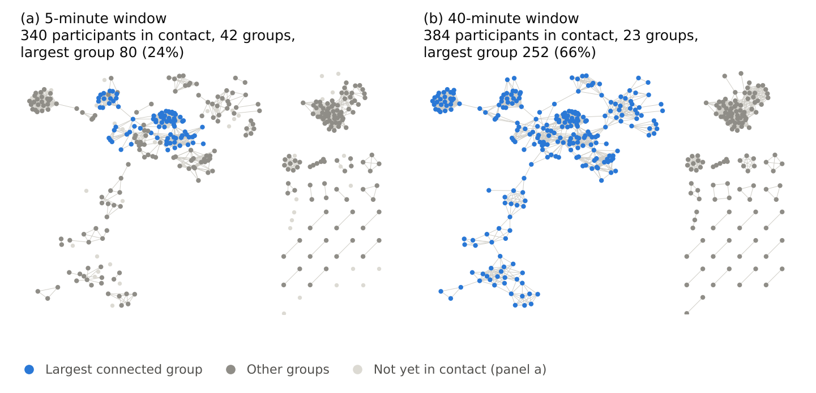
Fig. A1. Bluetooth proximity network in a typical weekday window (week 3, Monday, 13:00), aggregated over (a) 5 and (b) 40 minutes; node positions are the same in both panels. Data from Sapiezynski et al., Copenhagen Networks Study.
Table A2
Text Messages by Sender and Recipient Gender
Sender → recipient | Messages | Share of messages | Distinct pairs
Man → man | 7,287 | 31.6% | 732
Man → woman | 6,227 | 27.0% | 173
Woman → man | 6,766 | 29.3% | 176
Woman → woman | 2,789 | 12.1% | 134
Total | 23,069 | 100.0% | 1,215
Note: The notebook’s merge drops 1,264 of 24,333 messages that involve a participant without a gender record. Women sent 41.4% of the remaining messages and received 39.1%.
Source: Author’s analysis of Sapiezynski et al., Copenhagen Networks Study.
Table A3
Headline Findings: Article versus Re-analysis
Measure | Article | Re-analysis
Data availability, median participant | 0.81 (p. 4) | 0.806
Pairs ever in contact: 4 weeks; 1 week | 30%; 10–20% (p. 6) | 32.0%; 10.6–16.1%
Texts; calls in top 1% co-located pairs | 56%; 47% (p. 8) | 55.7%; 47.1%
Texts in top 15% co-located pairs | Over 80% (p. 6) | 80.0%
Calling pairs ever in contact | 89% (p. 6) | 82.9%
Calls made by pairs ever in contact | Not reported | 88.8%
Texts per call | About 10 (p. 6) | 6.8
Mean contacts: 5-minute; 24-hour window | About 2; 30 (p. 6) | 2.5; 25.3
Largest group: 5-minute; 40-minute window | Grows (p. 6) | 23%; 70%
Off-hours share: proximity; texts; calls | Higher for texts and calls (p. 6) | 17.6%; 48.6%; 43.2%
Distinct pairs: calling; ever in contact | Not reported | 621; 79,530
Note: “Contact” means Bluetooth contact. Pair shares are of all 248,865 possible pairs among the 706 participants. Five- to forty-minute figures are medians over 40 weekday windows starting at 10:00 and 13:00; 24-hour figures are medians over the 20 weekdays, from midnight. Mean contacts are per participant; largest-group shares are of participants active in the window. Off-hours are weekday evenings (18:00–24:00) and weekends. The article’s 89% matches the share of calls (88.8%) more closely than the share of calling pairs (515 of 621). “About 10” paraphrases its “an order of magnitude.”
Source: Sapiezynski et al., “Interaction Data”; author’s analysis of Sapiezynski et al., Copenhagen Networks Study.
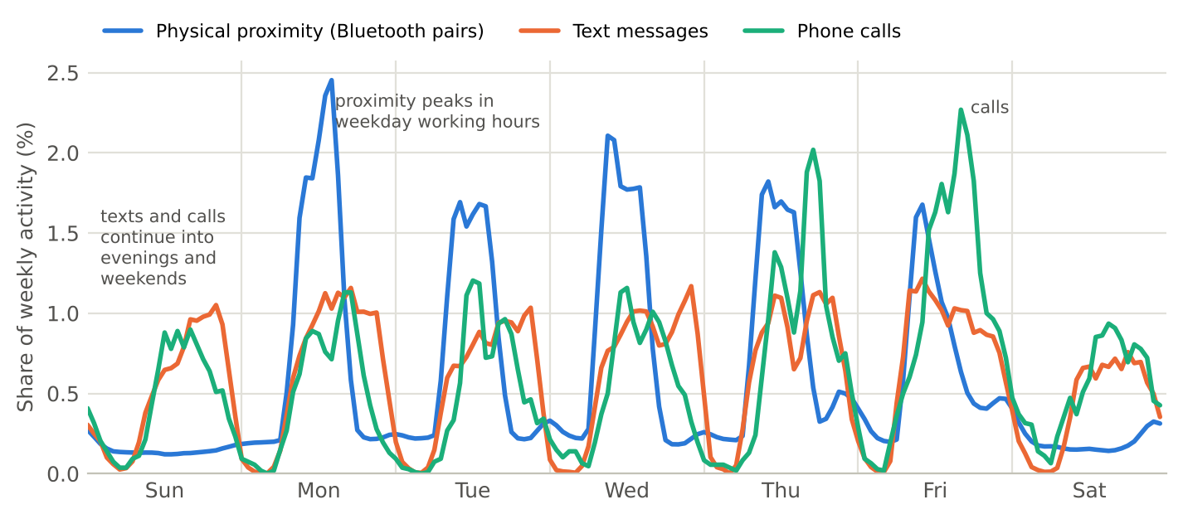
Fig. A2. Weekly rhythm by channel: each channel’s share of its weekly activity in each hour, averaged over four weeks (three-hour moving average). Data from Sapiezynski et al., Copenhagen Networks Study.

